**Comp1168 LabNo1**

Name: Kadiri Osilama

CRN:

Student Id: 101521804

Date: Thursday 11th January 2024

**Question1**

[copy the SQL Code for the query here!]

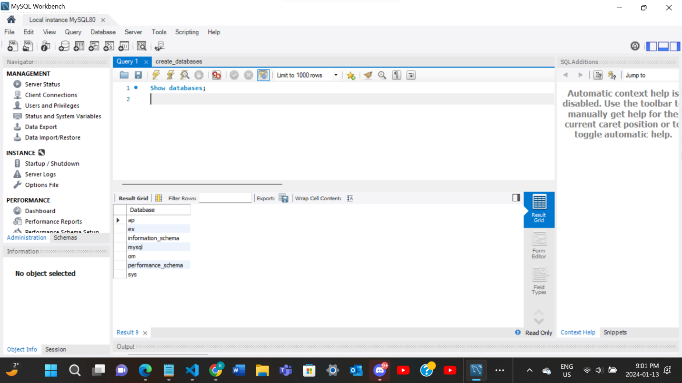

**Question2**

[copy the SQL Code for the query here!]

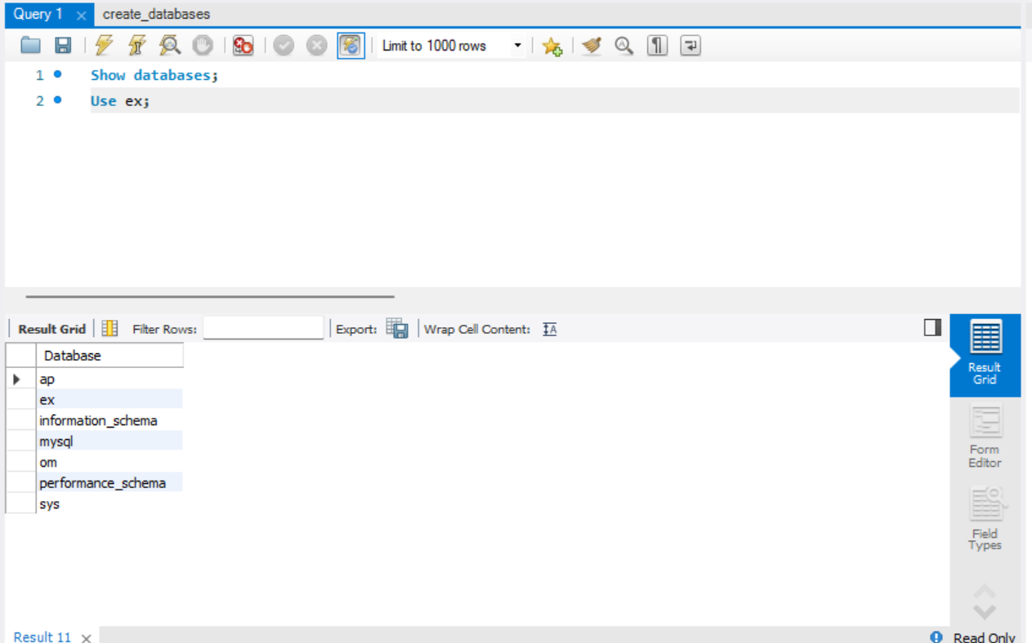

**Question3**

[copy the SQL Code for the query here!]

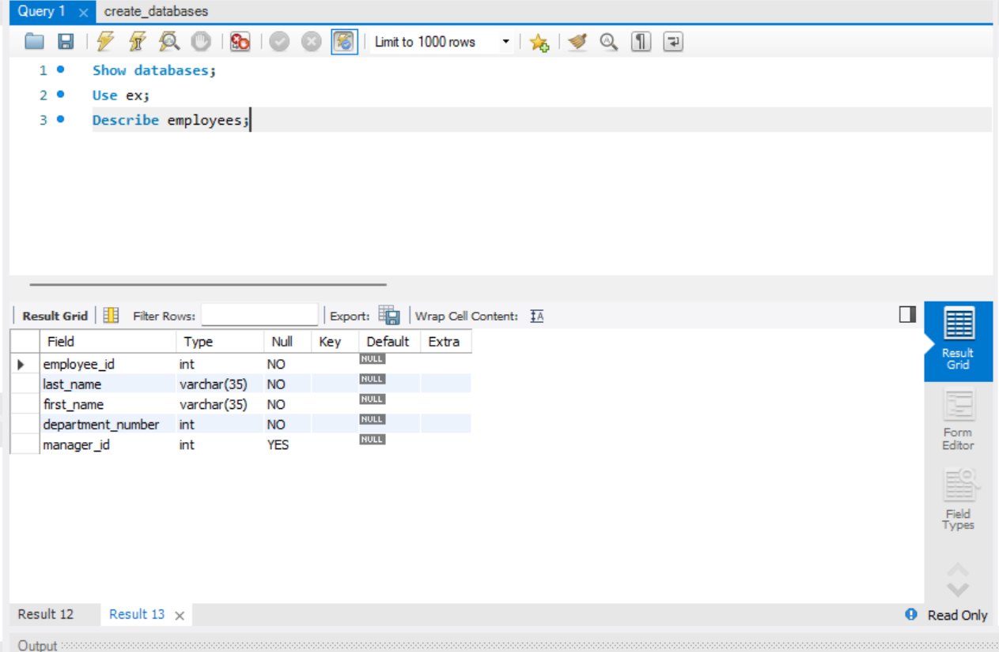

**Question4**

[copy the SQL Code for the query here!]

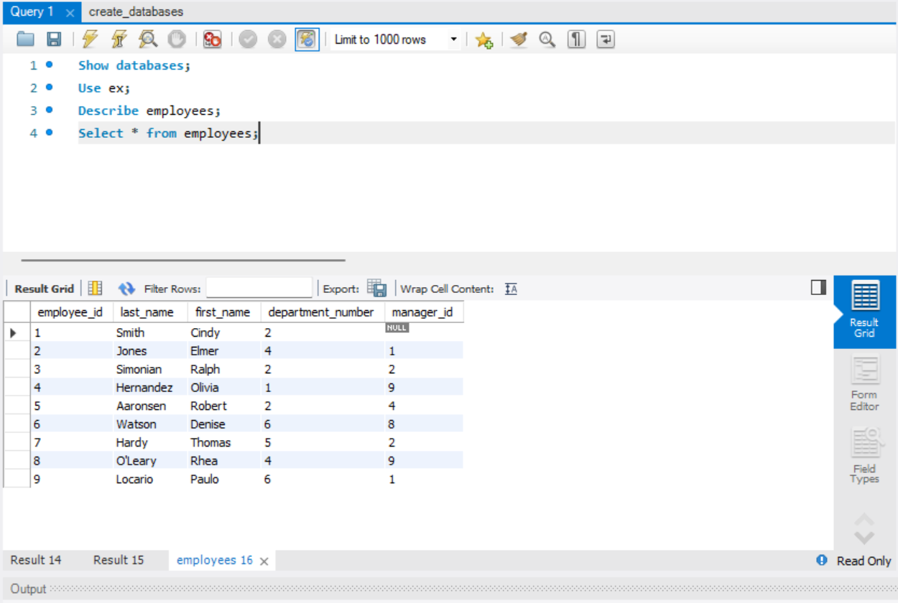

**Question5**

[copy the SQL Code for the query here!]

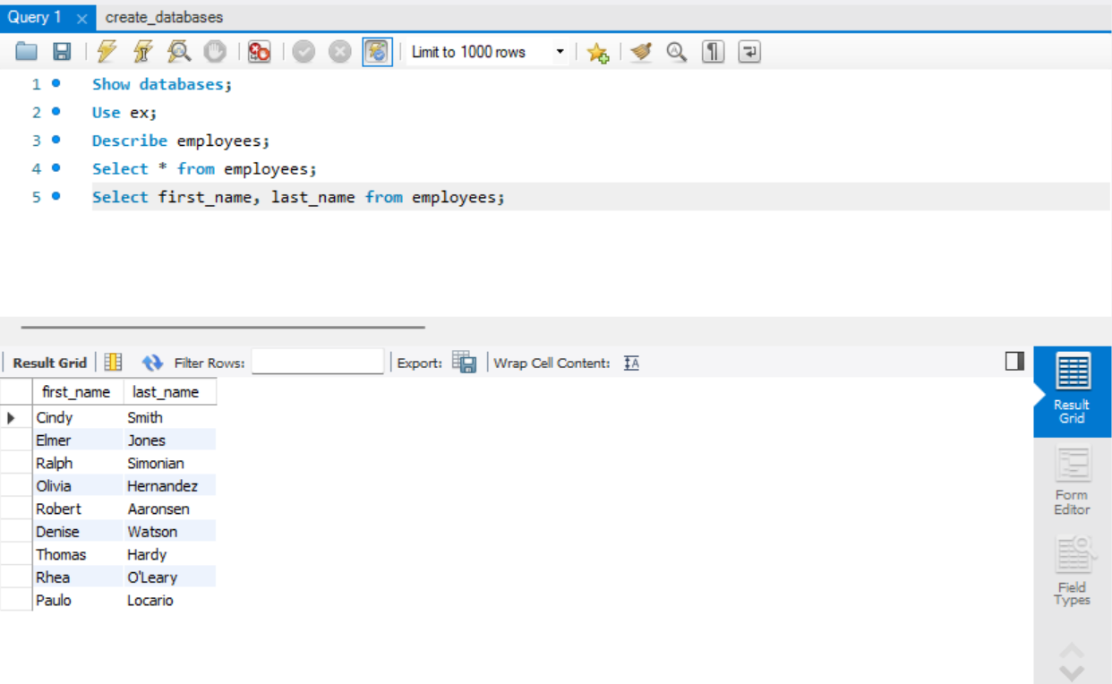

**Question6**

[copy the SQL Code for the query here!]

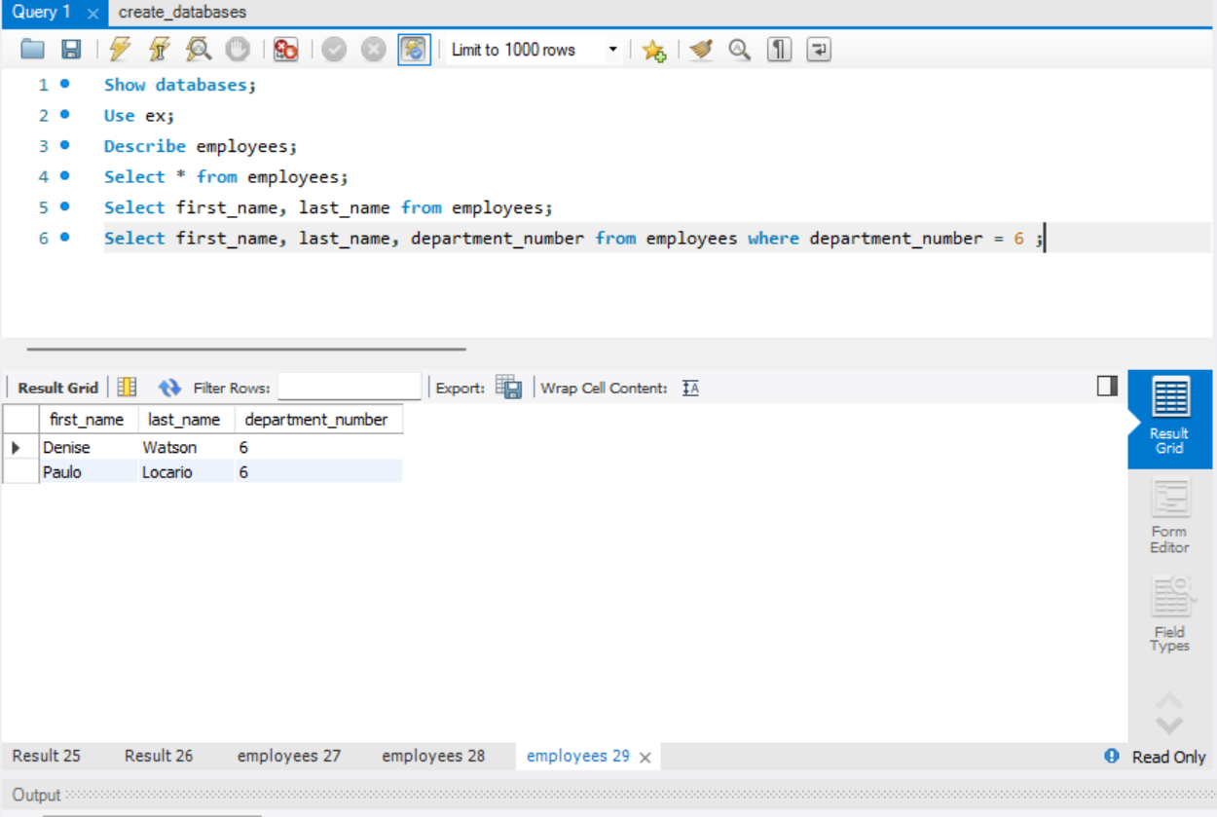

**Question7**

[copy the SQL Code for the query here!]

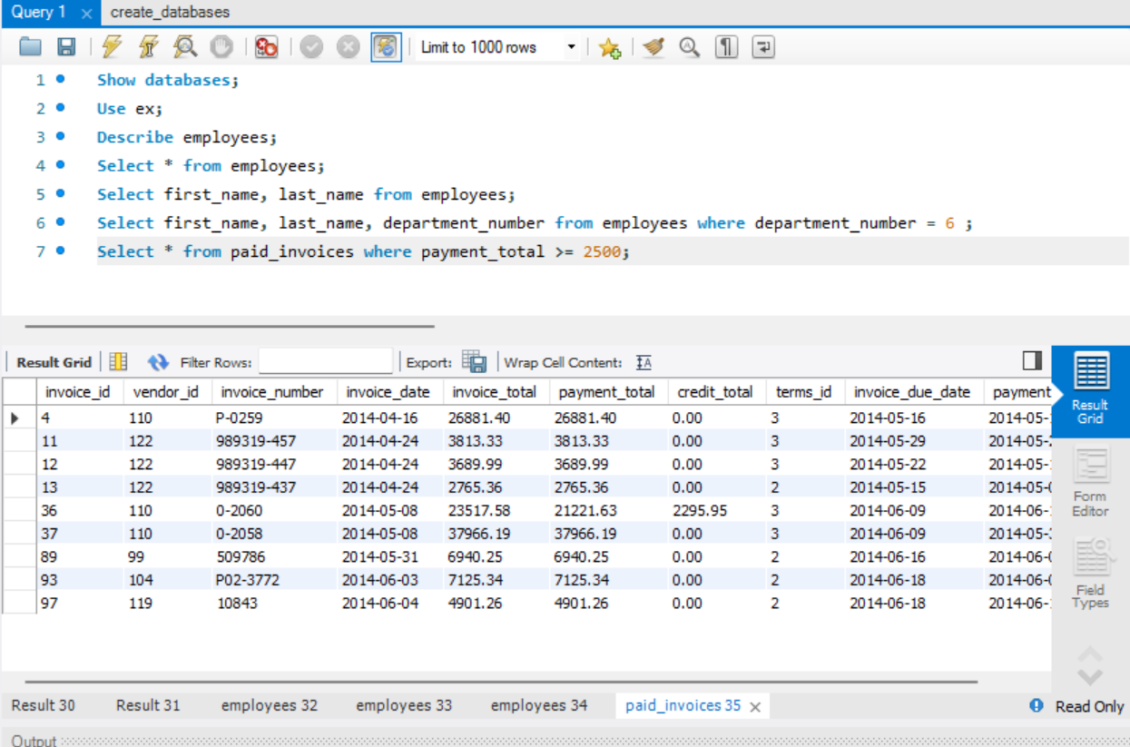

**Question8**

[copy the SQL Code for the query here!]

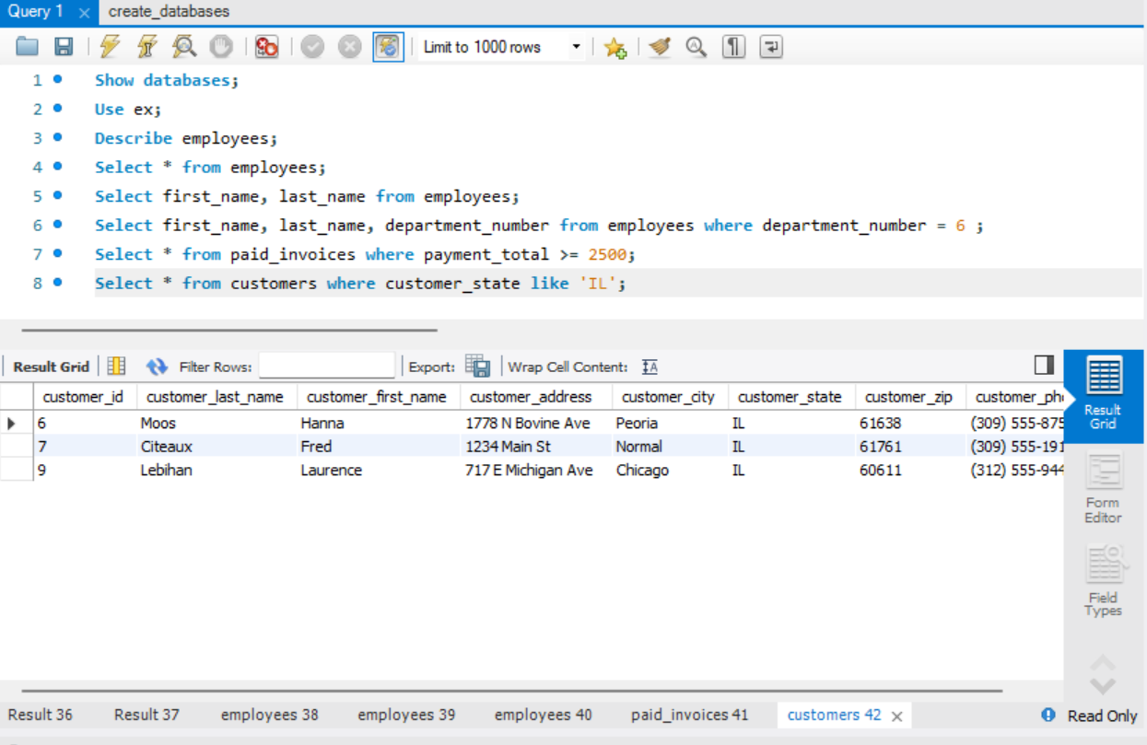

**Question9**

[copy the SQL Code for the query here!]

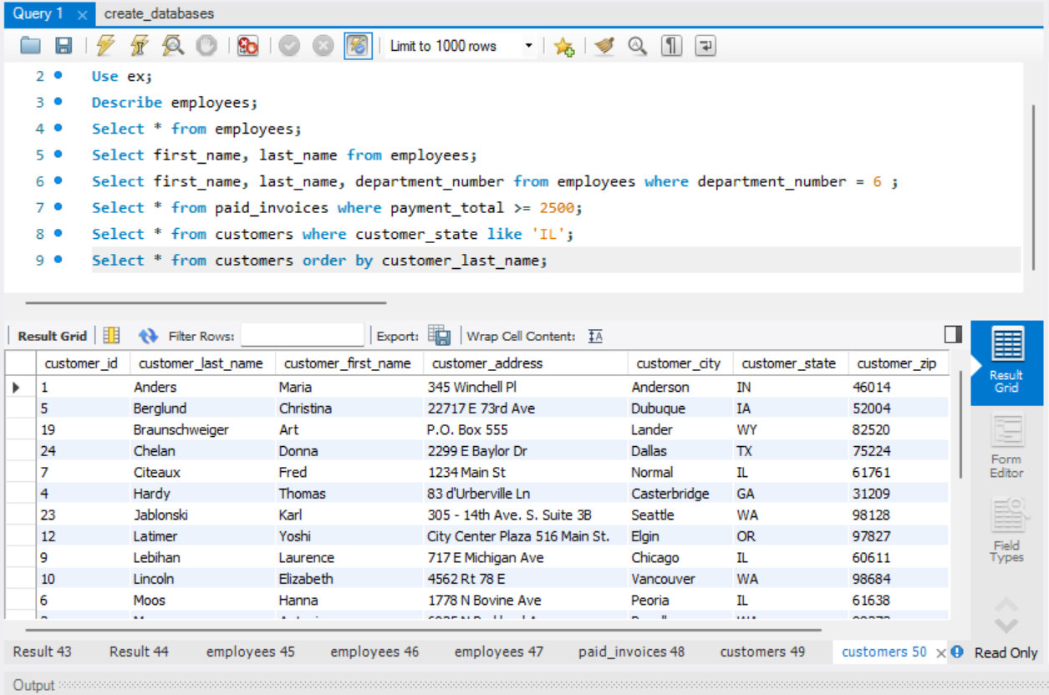

**.... Question?**